# **Question 1 : Vẽ bìa**

# Đề 1 : Complete all parts of the first page of the software requirements specification. (1 point) (Làm trang bìa đầu tiên cho tài liệu SRS)

* ĐÁP ÁN

**Software Requirements Specification**

**for**

**<Project> (FU Library Management System website)**

**Version 1.0 approved**

**Prepared by Phạm Thị Kim Thoa_HE181514**

**FPT University Campus Hòa Lạc**

**July 24, 2024**

# **Question 2 : Use Case dia**

# Đề 1 : Điền từ

Use case diagram is an effective way to visualize the interaction between actors and the software system. One Use case diagram need one rectangle which represents one system or one software application. One oval represents one use case. The name of the use case must begin with the verb and follow by an object.

1. In this exam paper, the name of the rectangle is: ………( 0.1 point)

<TÊN CỦA CÁI SYSTEM ĐÓ : VD : FU Library Management System website>

1. The actor may be human, other software systems or devices. In this exam paper, list the name of >= 3 actors is: ……..(0.6 point)
2. In this exam paper, list the name of >= 5 use cases are: …….(1 point)
3. The actors are inside or outside of the rectangle? ……… (0.1 point)
4. The ovals represent the use cases are inside or outside of the rectangle? ………(0.1 point)
5. The primary actor of the use case **add new question** is: …….(0.2 point)
6. The secondary actor of the use case **add new question** is:….. (0.2 point)
7. Based on the fact you already used EduNext website. The use cases in this exam paper may have relationship.

8.a List the name of two use cases that have **extend** relationship: …….(0.3 point)

8.b The name of **base use case (in 8.a)** is: …..(0.2 point)

8.c The name of **included use case (in 8.a)** is: ……(0.2 point)

8.d The dashed line with an arrow that points to which use case? …..(student write the name of use case) (0.1 point)

1. Based on the fact you already used EduNext website, the use cases in this exam paper may have relationship.

9.a List the name of two use cases that have **include** relationship: …….(0.3 point)

9.b The name of **based use case (in 9.a)** is: …..(0.2 point)

9.c The name of **extend use case** **(in 9s.a)** is: ……(0.2 point)

9.d The dashed line with an arrow that points to which use case? …… (student write the name of use case) (0.2 point)

# Đề 2 :



# Đề 3 :

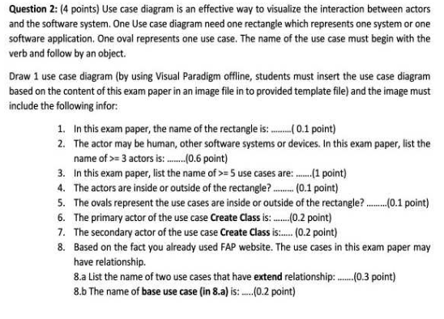

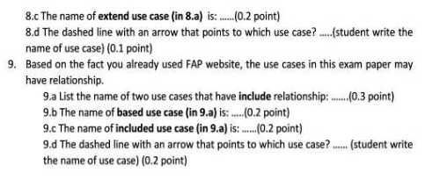

# **Question 3 : UC detail**

# Đề 1 :

Writing detail one use case, the use case **adds (+) new question** in the following format. (4 points)

1. UC ID and Name: (0.1 point).
2. Created By: (0.1 point).
3. Date Created: (0.1 point).
4. Primary Actor: (0.2 point).
5. Secondary Actors: (0.2 point).
6. Trigger: (0.3 point).
7. Description: (0.1 point)
8. Preconditions: (0.3 point).
9. Postconditions: (0.3 point).
10. Normal Flow: 0.7 point).
11. Alternative Flows: (0.7 point).
12. Exceptions: …..(0.3 point).
13. Priority: (0.1 point).
14. Frequency of Use: (0.1 point).
15. Business Rules: (0.2 point).
16. Other Information: (0.1 point).
17. Assumptions: (0.1 point).

## **MẪU DETAILED UC**

|  |  |  |  |
| --- | --- | --- | --- |
| **Use Case Specification** | | | |
| **Use Case ID and Name:** | SALES.MGT.01 – Create an order  <Mã số UC> - <Tên UC> | | |
| **Created By:** | Phạm Thị Kim Thoa | **Date Created:** | July-24, 2024 |
| **Primary Actor:** | Cashier  **<người sử dụng chức năng này chính>** | **Secondary Actors:** | **<người sử dụng chức năng này phụ >** |
| **Trigger:** | A cashier indicates that he/she wants to create an order upon receiving a customer’s request to make a purchase  <**Điều gì khiến** UC này được gọi, **mục đích** của việc sử dụng UC; *ví dụ: The admin indicates that he wants to udate a product*> | | |
| **Description:** | The “create an order” use case represents the process performed by the cashier to create a new order for a customer at a super market/convenience store. The cashier uses a barcode reader to scan sold products. The casher then handles the payment, either via cash or wallet/card, and finalizes the order. | | |
| **Preconditions:** | PRE-1: The barcode reader, printer is connected and functioning correctly  PRE-2: The card-reader/payment gateway device, is connected and functioning correctly  PRE-3: The cashier is logged into the system (appropriate authorization)  <Điều kiện tiên quyết cần có trước đó để UC này có thể chạy, *ví dụ: data/thiết bị sẵn dùng là…; user cần phải login trước khi sử dụng*> | | |
| **Post–conditions:** | POST-1: The order is successfully created and stored in the system  POST-2: The membership info is updated to reflect the customer purchase  POST-3: The inventor is updated to reflect the products purchased  <Sau khi UC thực thi xong và thành công, hiện trạng hệ thống là gì, user đạt được điều gì; có thể liệt kê thêm kết quả của tình huống UC thực thi thất bại, *ví dụ: Đơn hàng được ghi nhận và lưu trữ*> | | |
| **Normal Flow:** | 1. The cashier initiates the “Create an order” use case by selecting the menu “Create new order” on the system 2. The cashier asks the customer if he/she would like to record his/her purchase for membership benefits (by asking the customer the phone number) 3. The system activates the barcode reader to allow scanning products [see 1-AF] 4. The cashier scans each product’s barcode using the barcode reader [see 1-AF] 5. For each scanned product, the system identifies the product details: id, name, price, quantity, promotion (if any) and adds the item into the order 6. The system calculates the total order amount at whole 7. After scanning all of the desired products, the casher asks the customer for the preferred payment method (cash, wallet, card) [see 2-AF] 8. The customer chooses the “Cash” payment option [???phiếu quà tặng thay tiền mặt] 9. The cashier confirms the payment and finalizes the order 10. The system updates the inventory accordingly, generates/prints the receipt/bill and returns to the customer, update membership benefits (if any) | | |
| **Alternative Flows:** | 1-AF: The barcode reader fails to scan a product/doesn’t work correctly   1. The casher manually enters the product details including the product code and quantity via GUI [??? Nhập sai mã s/p] 2. For each manually entered product, the system identifies the product details: id, name, price, quantity, promotion (if any) and adds the item into the order 3. Return to STEP 6 (NF) of normal flow   2-AF: The customer chooses the “wallet” payment option   1. The system checks the customer’s wallet balance to ensure it covers the total order amount 2. If the wallet balance is sufficient, the system deducts the amount from the customer’s wallet [??? Tiền trong ví ko đủ] 3. Return to STEP 9 (NF) of normal flow   ?-AF: | | |
| **Exceptions:** | 1. EF: At any time, the app cannot communicate with the server/core system (due to network malfunction/technical issues), the system displays an error message. The cashier calls the technical support for supporting purpose 2. <Các tình huống ngoại lệ, người dùng làm gì tiếp, hệ thống phản hồi theo kiểu để UC kết thúc không thành công, App hạ cánh an toàn; **HOẶC TÌM CÁCH ĐI TIẾP USE CASE ĐỂ KẾT THÚC THÀNH CÔNG 23/7/2023**> | | |
| **Priority:** | **High (Medium, Low)**  <Mức độ ưu tiên cần hiện thực tính năng này, ví dụ: Must Have | High> | | |
| **Frequency of Use:** | **High** (ảnh hưởng đến UI/UX, dính đến nonfunctional requirements), nếu tần suất sử dụng tính năng này cao, thì có chiến lược design/implement tính năng này sao cho hiệu quả; để sau này khi đem vào sử dụng phải cực kì hiệu quả, nhanh gọn cho phía user | | |
| **Business Rules:** | **BR-1:** The system must support different payment method (cash, wallet, card…)  **BR-2:** The payment process has an option to record the customer payment by using physical voucher  **BR-3:** Using phone number to record/keep track the customer membership info  <Những câu phát biểu của khách hàng/user đưa ra để gài/khống chế/ràng buộc cái ngữ cảnh hoạt động của một tác vụ/công việc/tính năng/chức năng mà người dùng vẫn làm và thao tác hàng ngày; còn gọi là những quy tắc xử lí thông tin, *ví dụ 1: Ngày giờ phải theo định dạng dd/mm/yyyy HH:MM, giờ đồng hồ theo thang đo 24 giờ; ví dụ 2: Đơn hàng từ 1.000.000đ sẽ giảm giá x% theo thông tin khuyến mãi tại thời điểm tạo đơn*> | | |
| **Other Information:** |  | | |
| **Assumptions:** |  | | |

## CÁC MẪU KHÁC VỀ UC DESCRIPTION

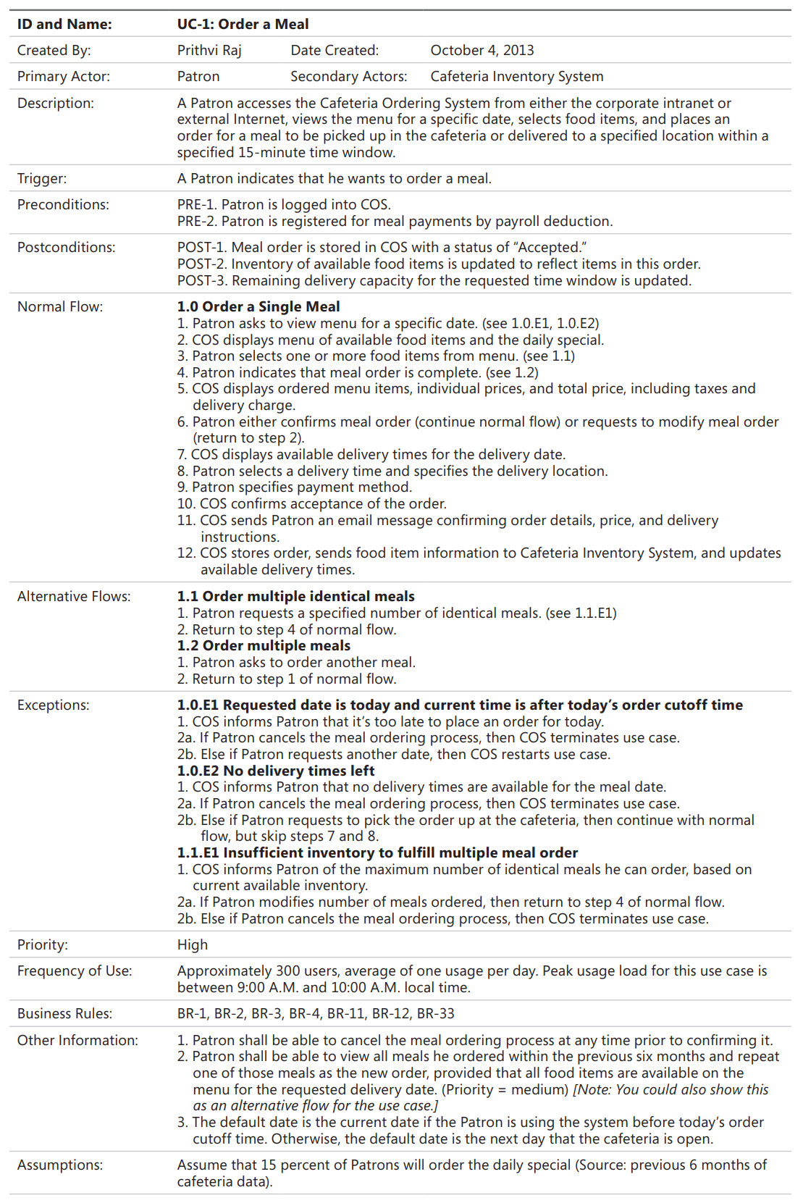

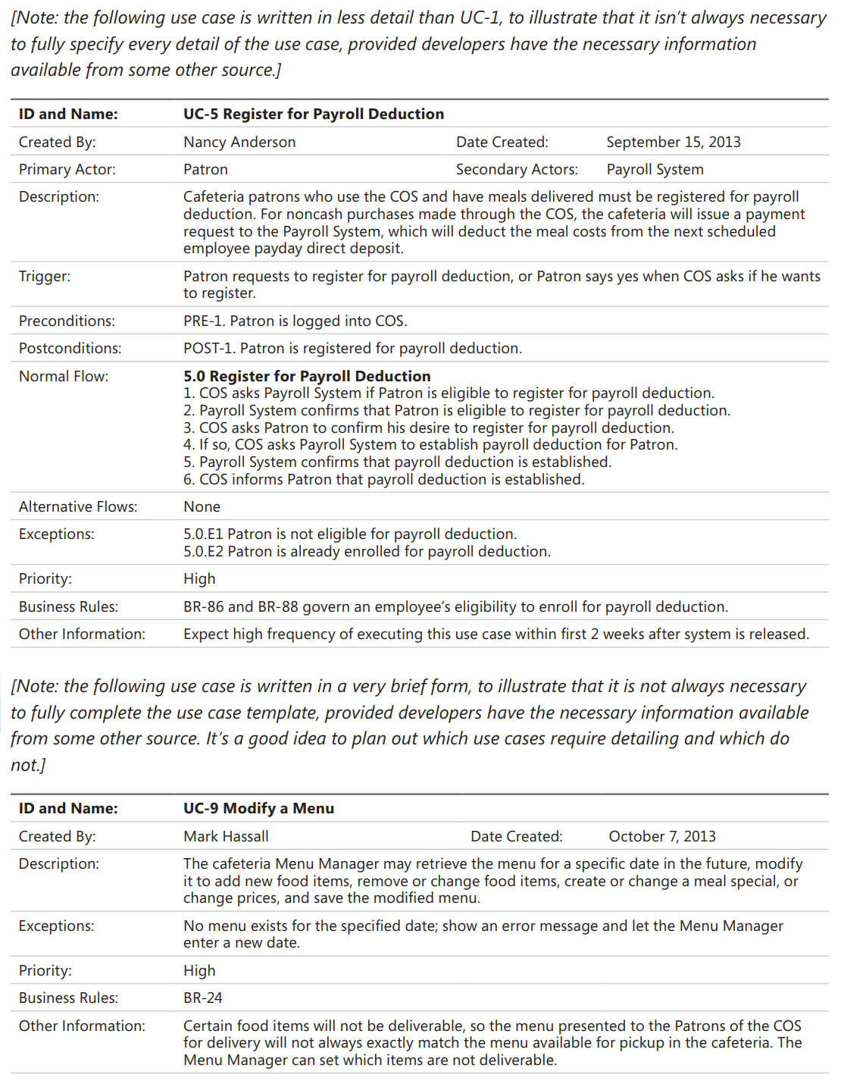

# **Question 4 : Non-func**

# Đề 1 : Writing 2 non-functional requirements.

1. The term of the most important non-functional requirements and at least 2 statements. Should be specific in number, explain the number so that the tester can test the software and make conclusion the test is passed or failed. (0.5 point)
2. The term of the second important non-functional requirement and at least 2 statements. Should be specific in number, explain the number so that the tester can test the software and make conclusion the test is passed or failed. (0.5 point)

# **Question 5 : Context-diagram**



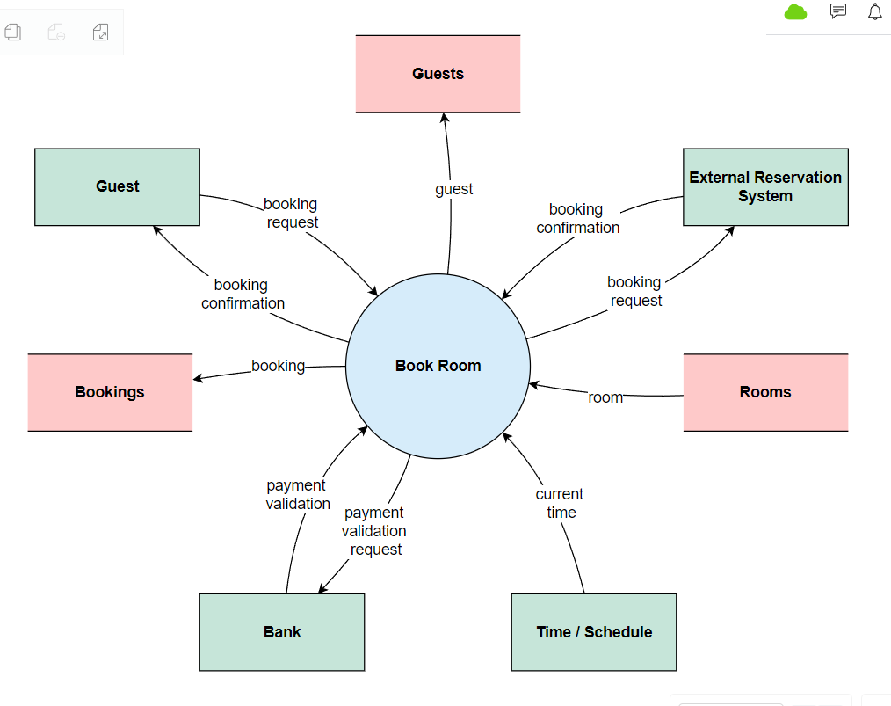

# **Question 6 : Business-rule**



# **CÁC LOẠI BIỂU ĐỒ KHÁC**

CÁCH CHỌN CÁC TEMPLATE TRONG VISUAL-DIA

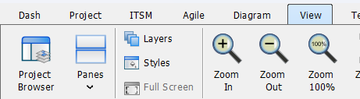

CHỌN VIEW => PROJECT Brower

CÁCH TÌM 1 TEMPLATE MỚI

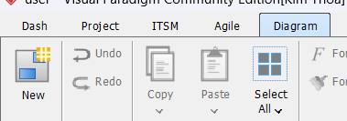

CHỌN Diagram => New

# BIỂU ĐỒ XƯƠNG CÁ

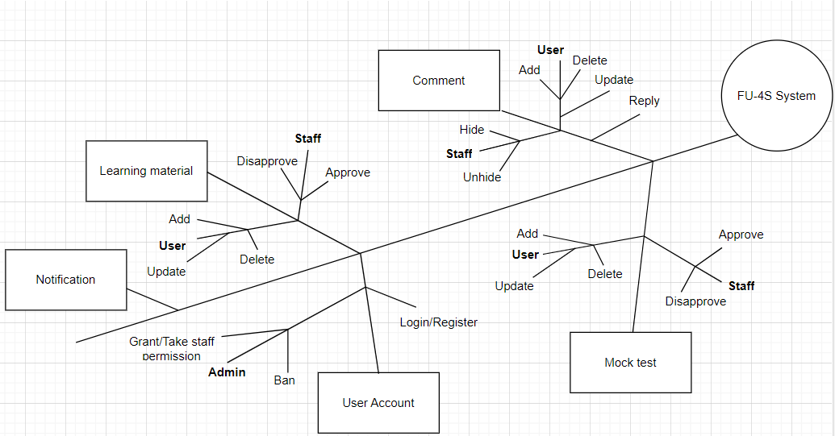

# BIỂU ĐỒ SWIMLANE

